Nama : Andyan Yogawardhana

NIM : 21/482180/PA/21030

Kelas : KOM B

1. Hewan

abstract class Makan {      // abstract

    private String makanan;

    public *void* setMakanan(String *food*) {   // encapsulation (setter)

*this*.makanan = *food*;

    }

    public String getMakanan() {    // encapsulation (getter)

        return *this*.makanan;

    }

    public *void* eat() {

        System.out.println("Makan " + makanan);

    }

}

class Karnivora extends Makan {    // inheritance

    public Karnivora() {

        setMakanan("daging");

    }

    public *void* eat() {

        System.out.println("Makan " + getMakanan());

    }

}

class Herbivora extends Makan {    // inheritance

    public Herbivora() {

        setMakanan("tumbuhan");

    }

    public *void* eat() {

        System.out.println("Makan " + getMakanan());

    }

}

class Omnivora extends Makan {    // inheritance

    public Omnivora() {

        setMakanan("daging dan tumbuhan");

    }

    public *void* eat() {

        System.out.println("Makan " + getMakanan());

    }

}

public class Hewan {

    public static *void* main(String[] *args*) {

        Makan Karnivora1 = **new** Karnivora();     // polymorphism

        Karnivora1.eat();

        Herbivora Herbivora1 = **new** Herbivora();

        Herbivora1.eat();

        Omnivora Omnivora1 = **new** Omnivora();

        Omnivora1.eat();

    }

}

Screenshot Program

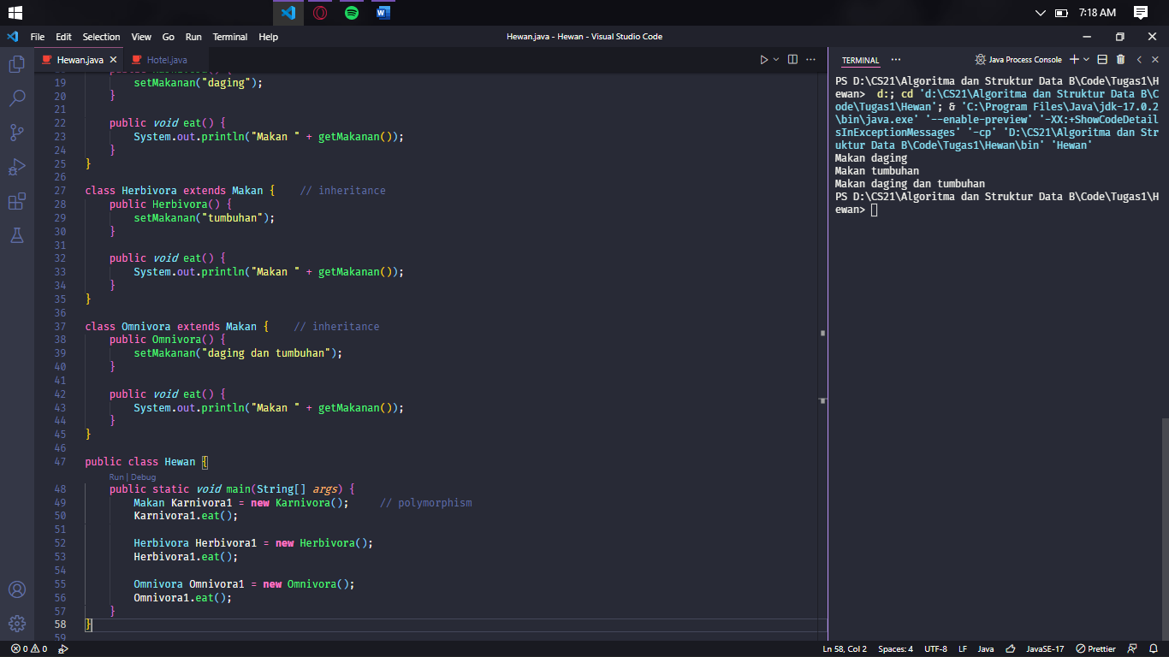

2. Hotel

class Kamar {

    public String nama;

    public *int* nomor;

    public *boolean* status = true;

    public Kamar(*int* *nomor*) {

*this*.nomor = *nomor*;

    }

    public String pesanKamar(String *nama*) {

*this*.status = false;

        return *this*.nama = *nama*;

    }

    public *void* statusKamar() {

        if(status) {

            System.out.println("Kamar " + *this*.nomor + " : Kosong");

        }

        else {

            System.out.println("Kamar " + *this*.nomor + " : Terisi " + *this*.nama);

        }

    }

}

class Pesan {

    Kamar[] kamar = **new** Kamar[10];

    public Pesan() {

        for(*int* i = 0; i < kamar.length; i++) {

            kamar[i] = **new** Kamar(i+1);

        }

    }

    public Kamar getRoom(*int* *i*) {

        return kamar[*i*-1];

    }

}

public class Hotel {

    public static *void* main(String[] *args*) {

        Pesan hoho = **new** Pesan();

        hoho.getRoom(1).statusKamar();

        hoho.getRoom(1).pesanKamar("Joni");

        hoho.getRoom(1).statusKamar();

        hoho.getRoom(9).statusKamar();

        hoho.getRoom(9).pesanKamar("Parker");

        hoho.getRoom(9).statusKamar();

    }

}

Screenshot Program

